Literature Review for COE374

Ryan Ylagan

**A Small UAV for Immediate Hazard Map Generation (2007)**

The main objective of the proposition outlined in the article was to create an unmanned aerial vehicle (UAV) that would collect images using an on-board digital camera and would use those images to assess an area where a natural disaster has occured. The images would then be transmitted to a ground station where it would then be assessed and analyzed, specifically for the use of rescue teams. The UAV would be equipped with an on-board avionics board that handles the flight navigation of the vehicle. Lastly, the data collected is integrated with a spatial temporal Geographic Information System (GIS) that would relay the image data and related information e.g. collection position and time.

The paper goes on to explain some case studies and flight tests that confirm that an autonomous guidance system of a UAV is feasible. One particular case study described included a UAV collected high-resolution colored images of areas recently affected by a large earthquake in Japan that would be hard to reach otherwise.

Overall, this paper is really useful to show that a project like ours is possible and has already been done. It provides many figures that we may find useful to display on our slides and it also gives us a few case studies that we can reference.

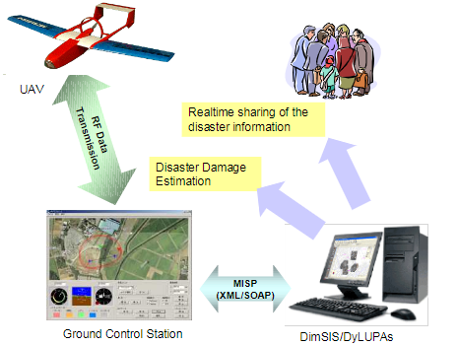

**Source**

<https://arc.aiaa.org/doi/10.2514/6.2007-2725>

**Improving UAV-Based Target Accuracy through Automatic Camera Parameter Discovery (2020)**

In recent years, drones have begun to excel at performing automated tasks when fed certain algorithms and mounted with the best hardware. One such task is target geolocation, where a mounted camera can be used to identify the specific location of targets using software. There are, however, certain factors that may inhibit the function of or affect the accuracy of target geolocation making the target recognition imperfect. These factors are lens distortion, timing, multiple detections, and camera angle calibration.

Lens distortion refers to how light may enter the sensor in a non-linear manner which then degrades the accuracy of position estimates. The two most common types of lens distortion encountered are Barrel Distortion and Pincushion distortion. The paper suggests using OpenCV to calibrate the lens configuration.

Timing is incredibly important, otherwise there may be discrepancies and inaccuracies in geolocation. There are two timing concerns mentioned in the paper; communication frequency and latency problems, and image capture latency. The former is avoided by having the camera system interpolate it’s current position using last communicated position and velocity, as well as the time elapsed. The latter occurs due to the shutter speed of the camera or the auto-focus and auto-exposure settings, but can be fixed using latency estimation.

Accuracy of the target location can be improved through averaging multiple samples together. The paper helps understand the statistical output variance of various factors.

Lastly, camera angle calibration is an important problem as small degree errors on the camera mount can drastically affect measurements when flying at higher altitudes. The paper suggests a method to determine the camera’s pitch, roll, and yaw offset parameters by creating an optimization problem.

Using a Raspberry Pi camera, these four problems and their respective mitigation strategies were tested and were found to improve geolocation accuracy by more than 100%. Figures displaying such are given in the paper.

This paper may be useful in highlighting what problems we may encounter when working with our on-board camera. The problems outlined in the paper are purely software, so there’s a good chance we may see them. It mentions the use of a Raspberry Pi camera and its features (which we may be using, not sure). Furthermore, it provides us with solutions to these problems.

**Source**

<https://doi.org/10.2514/6.2020-2201>

**Automatic Target Recognition Directed Image Compression (1999)**

An increase in UAVs has led to a higher demand in bandwidth which would require the adoption of digital compression, leading to degraded imagery when communicating or transferring the data. The paper outlines a hybrid algorithm that uses automatic target recognition (ATR) that would work with the bandwidth limitations. Simply put, the algorithm uses regional compression to identify different areas of interest, which would then allocate more bits to these areas and less to more unimportant areas. This algorithm returns an image that has areas of high resolution where the targets of interest are, and low resolution in which contextual information is retained.

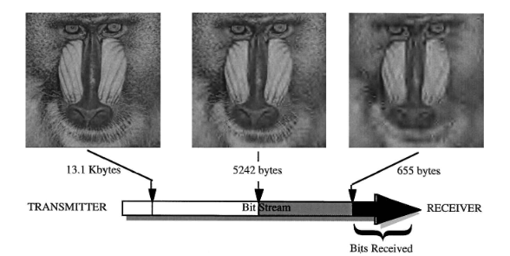

Think this paper is useful as we may need to implement a similar algorithm for higher quality photos that better highlight the targets of interest.

**Source**

<https://arc.aiaa.org/doi/10.2514/2.2502>